**WEB TECHNOLOGIES**

**LAB MANUAL**

Submitted in partial fulfilment of the requirements for the award of the degree of

**BACHELOR OF TECHNOLOGY**

(Information Technology)



|  |  |
| --- | --- |
| Submitted by: | **JASKARAN SINGH** |
| Submitted to: | **Prof. HANIT KAUR** |
| Branch: | **D2 IT-A3** |

Department of Information Technology, Guru Nanak Dev Engineering college Ludhiana-141106

**INDEX**

|  |  |
| --- | --- |
| **S NO.** | **Practicals** |
| **1** | Create a simple web page by writing HTML using a simple text editor, Notepad. Demonstrate the following components of the web page: Page titles and Headings Paragraphs and Inline images |
| **2** | Demonstrate the use of Links, Lists and Tables in HTML. You should be able to link separate pages and create named links within a document, using them to build a “table of contents”. |
| **3** | Create simple Forms in HTML and demonstrate the use of various form elements like input box, text area, submit and radio buttons etc. |
| **4** | Demonstrate the use of cascading style sheets (CSS) (inline, internal and external) to specify various aspects of style, such as colors and text fonts and sizes, in HTML document. |
| **5** | Creation of Web pages using HTML5 and CSS3. |
| **6** | Demonstrate the use of Bootstrap Framework. |
| **7** | Creating web pages using PHP. |

Practical 1🡺

Create a simple web page by writing HTML using a simple text editor, Notepad. Demonstrate the following components of the web page: Page titles and Headings Paragraphs and Inline images

HTML:

<!DOCTYPE html>

<html lang="en">

  <head>

    <meta charset="UTF-8" />

    <meta http-equiv="X-UA-Compatible" content="IE=edge" />

    <meta name="viewport" content="width=device-width, initial-scale=1.0" />

    <title>Practical 1</title>

  </head>

  <body>

    <h1>Web Technology Laboratory</h1>

    <h2>Professor: HANIT KARWAL</h2>

    <h3>Guru Nanak Dev Engineering College, Ludhiana</h3>

    <img

      src="https://www.gndec.ac.in/sites/default/logo.png"

      alt="gndec-logo"

      width="1000px"

    />

    <p>

      <strong>

        Guru Nanak Dev Engineering College (GNDEC or GNE Ludhiana)

      </strong>

      is one of the oldest engineering institutions of the northern region

      situated at Gill Park, Ludhiana, Punjab, India. The foundation stone of

      the college was laid on

      <em>8th April 1956 by Hon'ble Dr. Rajendra Prasad</em>, the first

      President of India. The college has been named after 1st Sikh Guru Guru

      Nanak Dev Ji.

    </p>

  </body>

</html>

IMAGE:



Practical 2🡺

Demonstrate the use of Links, Lists and Tables in HTML. You should be able to link separate pages and create named links within a document, using them to build a “table of contents”.

HTML:

<!DOCTYPE html>

<html lang="en">

  <head>

    <meta charset="UTF-8" />

    <meta http-equiv="X-UA-Compatible" content="IE=edge" />

    <meta name="viewport" content="width=device-width, initial-scale=1.0" />

    <title>Practical 2</title>

    <style>

      table,

      th,

      td {

        border: 1px solid black;

        border-collapse: collapse;

      }

    </style>

  </head>

  <body style="text-align: center">

    <h1>Practical 2 [Tables]</h1>

    <br />

    <table style="width: 50%; margin-left: auto; margin-right: auto">

      <tr>

        <th>Site Name</th>

        <th>Links</th>

        <th>Link Address</th>

      </tr>

      <tr>

        <td>Google</td>

        <td><a href="https://www.google.com/" target="_blank">Google</a></td>

        <td>https://www.google.com/</td>

      </tr>

      <tr>

        <td>Facebook</td>

        <td>

          <a href="https://www.facebook.com/" target="_blank">Facebook</a>

        </td>

        <td>https://www.facebook.com/</td>

      </tr>

      <tr>

        <td>GNDEC</td>

        <td><a href="https://www.gndec.ac.in/" target="_blank">GNDEC</a></td>

        <td>https://www.gndec.ac.in/</td>

      </tr>

    </table>

    <ol style="text-align: left">

      <strong>Ordered List</strong>

      <li>GNDEC</li>

      <li>Ludhiana</li>

      <li>Punjab</li>

    </ol>

    <ul style="text-align: left">

      <strong>Unordered List</strong>

      <li>GNDEC</li>

      <li>Ludhiana</li>

      <li>Punjab</li>

    </ul>

  </body>

</html>

IMAGE:

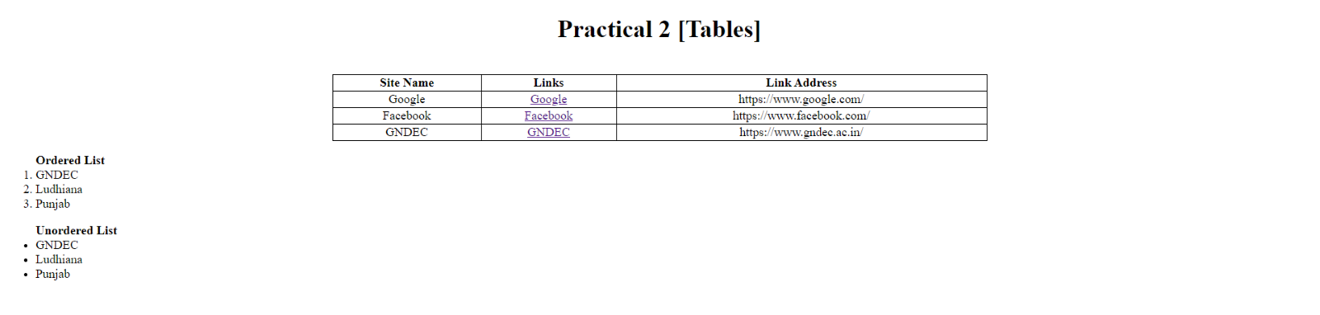

Practical 3🡺

Create simple Forms in HTML and demonstrate the use of various form elements like input box, text area, submit and radio buttons etc.

HTML:

<!DOCTYPE html>

<html>

<head>

<title>

PRACTICAL NO : 3

</title>

<style>

body{

background-color: rgb(44, 40, 40);

color: whitesmoke;

}

h1{

background-color: rgb(20, 19, 19);

color: whitesmoke;

text-align: center;

}

p{

/* background-color: rgb(19, 17, 17); */

font-size: 140%;

margin-left: 1%;

margin-right: 80%;

text-align: center;

}

input{

border: 1px solid rgb(226, 222, 222);

margin-top: 6px;

margin-bottom: 16px;

box-sizing: border-box;

padding: 12px;

border-radius: 4px;

}

#text1{

width: 20%;

}

label{

font-size: 130%;

}

#radio1{

font-size: 110%;

margin-left: 1%;

margin-right: 2%;

}

#check1{

font-size: 110%;

margin-left: 1%;

margin-right: 2%;

}

#check{

margin-left: 5%;

margin-top: 1%;

}

#button1{

background-color: rgb(68, 74, 85);

color: rgb(241, 228, 228);

text-align: center;

border: 2px solid whitesmoke;

display: inline;

font-size: 100%;

padding: 14px 40px;

border-radius: 12px;

}

</style>

</head>

<body>

<h1>SAMPLE FORM</h1>

<br>

<form id="form1">

<p>Personal Information :-</p><hr>

<label style="margin-left: 5%;">First Name : </label><input id="text1" type="text" placeholder="First name..">

<label style="margin-left: 19.5%;">Last Name : </label><input id="text1" type="text" placeholder="Last name..">

<br><label style="margin-left: 9.5%;">Age : </label><input id ="text1" type="number" placeholder="Age..">

<label style="margin-left: 20%;">Birth date : </label><input id="text1" type = "date" placeholder="date">

<br><label style="margin-left: 8%;">Gender : </label>

<input type="radio" id="male" name="Gender"><label for="male" id="radio1">Male</label>

<input type="radio" id="female" name="Gender"><label for="female" id="radio1">Female</label>

<input type="radio" id="other" name="Gender"><label for="other" id="radio1">Other</label>

<label style="margin-left: 18%;">Email : </label><input id="text1" type="email" placeholder="Ex-example@gmail.com">

<br><label style="margin-left: 6%;">Country : </label><input id="text1" type="text" placeholder="Country..">

<label style="margin-left: 24%;">State : </label><input id="text1" type="text" placeholder="State..">

<hr><p>Academic Details :-</p><hr>

<label style="margin-left: 5%;">School/college : </label><input id="text1" type="text" placeholder="School/college">

<label style="margin-left: 10%;">Board : </label>

<input type="radio" id="centreboard" name="Board"><label for="centreboard" id="radio1">CBSE</label>

<input type="radio" id="stateboard" name="Board"><label for="stateboard" id="radio1">State Board</label>

<br><label for="stream" style="margin-left: 5%;">Stream : </label>

<input list="stream" name="stream" style="margin-left: 5%;" placeholder="Stream..">

<datalist id="stream">

<option value="Medical"></option>

<option value="Non-medical"></option>

<option value="Commerce"></option>

<option value="Arts"></option>

</datalist>

<label style="margin-left: 10%;">Specify Board (If state board) : </label><input type="text" placeholder="ex : PSEB">

<hr><p>Other Details :-</p><hr>

<label style="margin-left: 5%;">Tick the options of your intrest :- </label><br>

<input type="checkbox" name="Hobbies" id="check"><label for="Hobbies" id="check1">Reading</label>

<input type="checkbox" name="Hobbies" id="check"><label for="Hobbies" id="check1">Listening music</label>

<input type="checkbox" name="Hobbies" id="check"><label for="Hobbies" id="check1">browsing</label><br>

<input type="checkbox" name="Hobbies" id="check"><label for="Hobbies" id="check1">Sports</label>

<input type="checkbox" name="Hobbies" id="check"><label for="Hobbies" id="check1">Technology facts</label>

<input type="checkbox" name="Hobbies" id="check"><label for="Hobbies" id="check1">Travelling</label><br>

<label style="margin-left: 5%;">Contact No. : </label><input type="number" placeholder="Mobile No.">

</form>

<button id="button1" type="submit" form="form1">SUBMIT</button>

</body>

</html>

IMAGE:

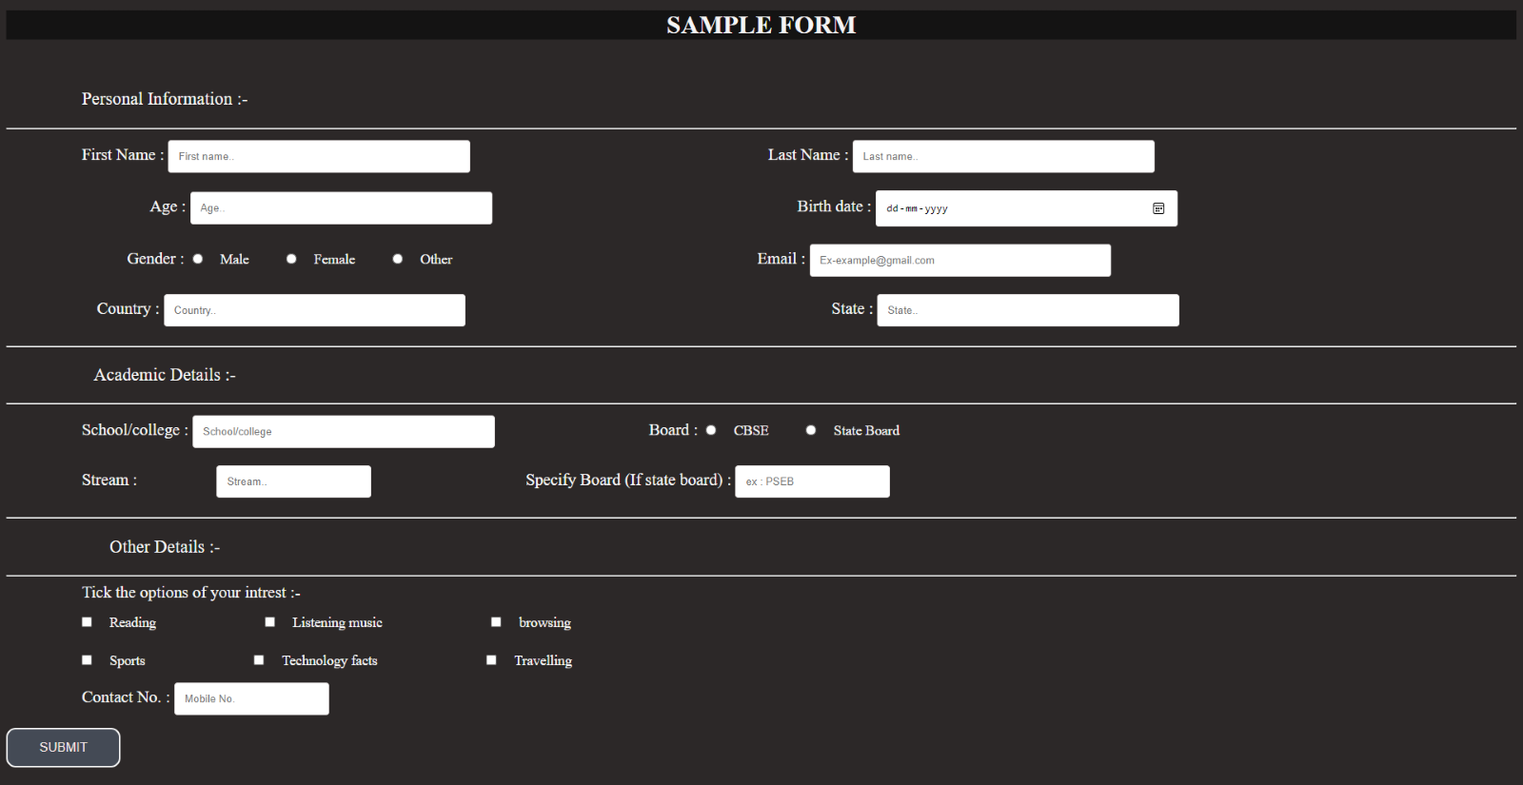

Practical 4🡺

Demonstrate the use of cascading style sheets (CSS) (inline, internal and external) to specify various aspects of style, such as colors and text fonts and sizes, in HTML document.

HTML:

<!DOCTYPE html>

<html lang="en">

  <head>

    <meta charset="UTF-8" />

    <meta http-equiv="X-UA-Compatible" content="IE=edge" />

    <meta name="viewport" content="width=device-width, initial-scale=1.0" />

    <title>Practical 4</title>

    <style>

      .internal {

        margin: 20px 50px;

        background-color: #3edbf0;

        color: #02475e;

        font-weight: 500;

        font-family: "Arial Narrow Bold", sans-serif;

        padding: 30px;

        border-radius: 20px;

      }

    </style>

    <link rel="stylesheet" href="./Practical-4.css" />

  </head>

  <body>

    <h1 style="text-align: center">Use of Cascading Style Sheets (CSS)</h1>

    <div style="text-align: center; font-size: 3em">

      Inline,Internal & External CSS

    </div>

    <div

      style="

        margin: 20px 50px;

        background-color: #ff8474;

        color: #02475e;

        font-weight: 500;

        font-family: 'Arial Narrow Bold', sans-serif;

        padding: 30px;

        border-radius: 20px;

      "

    >

      Inline CSS An inline style may be used to apply a unique style for a

      single element. To use inline styles, add the style attribute to the

      relevant element. The style attribute can contain any CSS property.

    </div>

    <div class="internal">

      Internal CSS An internal style sheet may be used if one single HTML page

      has a unique style. The internal style is defined inside the style

      element, inside the head section.

    </div>

    <div class="external">

      External CSS With an external style sheet, you can change the look of an

      entire website by changing just one file! Each HTML page must include a

      reference to the external style sheet file inside the <link /> element,

      inside the head section.

    </div>

  </body>

</html>

CSS:

.external {

  margin: 20px 50px;

  background-color: #fea82f;

  color: #02475e;

  font-weight: 500;

  font-family: "Arial Narrow Bold", sans-serif;

  padding: 30px;

  border-radius: 20px;

}

IMAGE:

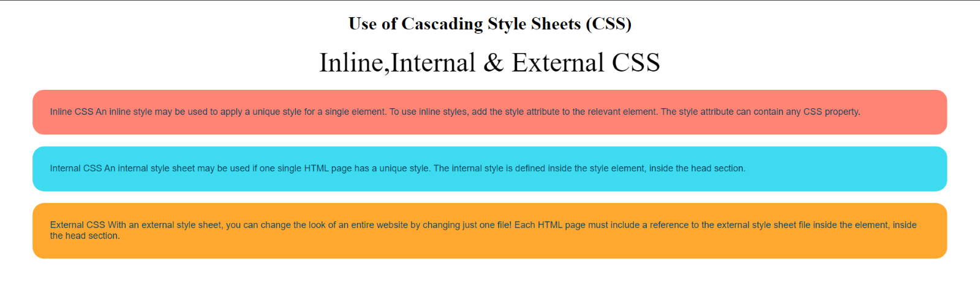

Practical 5🡺

Creation of Web pages using HTML5 and CSS3.

HTML:

<!DOCTYPE html>

<html lang="en">

  <head>

    <meta charset="UTF-8" />

    <meta http-equiv="X-UA-Compatible" content="IE=edge" />

    <meta name="viewport" content="width=device-width, initial-scale=1.0" />

    <title>Practical 5</title>

    <link rel="stylesheet" href="./Practical-5.css" />

  </head>

  <body>

    <header id="main-header">

      <div class="container">

        <h1>My Website</h1>

      </div>

    </header>

    <nav id="navbar">

      <div class="container">

        <ul>

          <li><a href="#">Home</a></li>

          <li><a href="#">About</a></li>

          <li><a href="#">Services</a></li>

          <li><a href="#">Contact</a></li>

        </ul>

      </div>

    </nav>

    <div class="container">

      <section id="showcase">

        <h1>

          Lorem ipsum dolor sit, amet consectetur adipisicing elit. In nesciunt

          quam molestias neque

        </h1>

      </section>

      <section id="main">

        <h1>Welcome</h1>

        <p>

          Lorem ipsum dolor sit amet, consectetur adipisicing elit. Repellat

          adipisci reiciendis a distinctio nihil natus! Consequatur libero

          sapiente fugiat unde harum earum odit quod accusantium rerum nesciunt

          est, asperiores recusandae nemo assumenda nisi distinctio totam.

          Similique neque pumenda nobis corrupti architecto totam earum

          perspiciatis quisquam at dolor reiciendis quidem ipsum debitis! Ad

          dolorum temporibus eum itaque! In non fugit distinctio repellat

          ducimus, a debitis quos!

        </p>

      </section>

      <aside id="sidebar">

        <p>

          Lorem ipsum dolor sit amet consectetur adipisicing elit. Dicta dolore

          necessitatibus rem quae, omnis eum libero quia excepturi, consequuntur

          magni fuga explicabo, incidunt quaerat repellendus reiciendis ad

          officiis molestias! Asperiores animi quam libero consequuntur commodi

          iure, corporis velit, et odio optio facilis quia temporibus magnam,

          porro cupiditate dolorem consequatur impedit!

        </p>

      </aside>

    </div>

    <footer id="main-footer">

      <p>Copyright 2021 &copy; Ekam Preet Singh 1921028/1905327</p>

    </footer>

  </body>

</html>

CSS:

body {

  background-color: #f4f4f4;

  columns: #555;

  font: Arial, Helvetica, sans-serif 16px;

  line-height: 1.6em;

  margin: 0;

}

.container {

  width: 80%;

  margin: auto;

  overflow: hidden;

}

#main-header {

  background-color: coral;

  color: #fff;

}

#navbar {

  background-color: #333;

  color: #fff;

}

#navbar ul {

  padding: 0;

  list-style: none;

}

#navbar li {

  display: inline;

}

#navbar a {

  color: #fff;

  text-decoration: none;

  font: 18px;

  padding-right: 15px;

}

#showcase {

  min-height: 100px;

  margin-bottom: 30px;

  text-align: center;

  margin: auto;

  width: 70%;

}

#showcase h1 {

  color: #333;

  font-size: 40px;

  line-height: 1.2em;

  padding-top: 30px;

}

#main {

  float: left;

  width: 70%;

  padding: 0 30px;

  box-sizing: border-box;

}

#sidebar {

  float: right;

  width: 30%;

  background-color: #333;

  color: #fff;

  padding: 10px;

  box-sizing: border-box;

}

#main-footer {

  background-color: #333;

  color: #fff;

  text-align: center;

  padding: 20px;

  margin-top: 40px;

  margin-bottom: 0;

}

IMAGE:

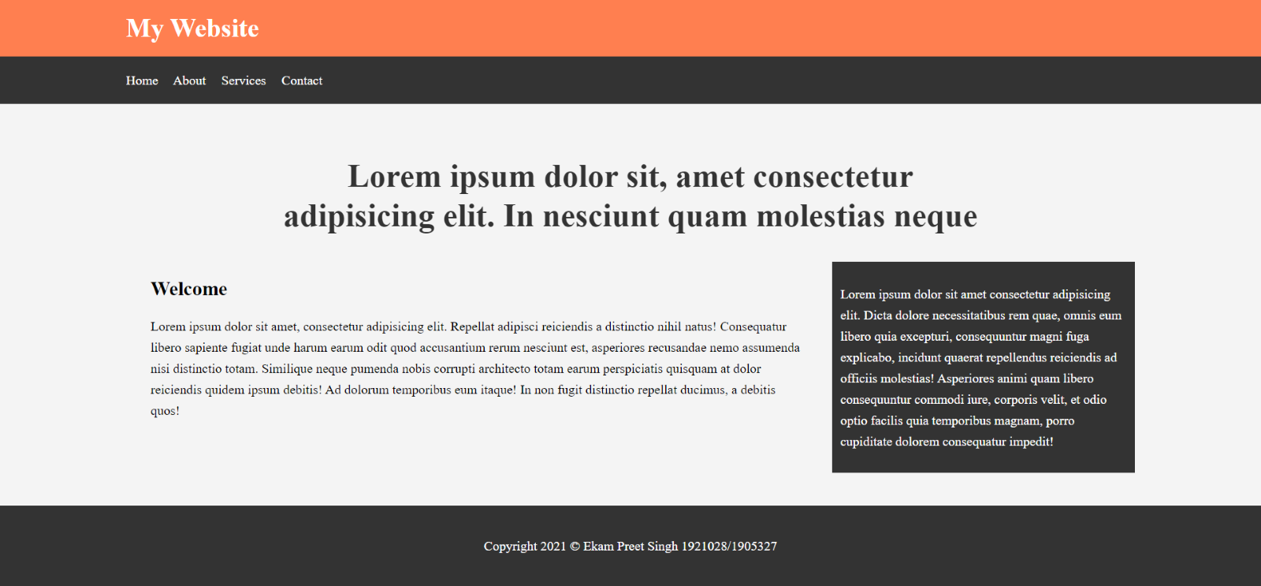

Practical 6🡺

Demonstrate the use of Bootstrap Framework.

HTML:

<!DOCTYPE html>

<html lang="en">

  <head>

    <meta charset="UTF-8" />

    <meta http-equiv="X-UA-Compatible" content="IE=edge" />

    <meta name="viewport" content="width=device-width, initial-scale=1.0" />

    <title>Practical 6</title>

    <link

      rel="stylesheet"

href="https://cdn.jsdelivr.net/npm/bootstrap@4.6.0/dist/css/bootstrap.min.css"

      integrity="sha384-B0vP5xmATw1+K9KRQjQERJvTumQW0nPEzvF6L/Z6nronJ3oUOFUFpCjEUQouq2+l"

      crossorigin="anonymous"

    />

  </head>

  <body style="padding: 50px">

    <nav class="navbar navbar-expand-lg navbar-dark bg-dark">

      <a class="navbar-brand" href="#">Navbar</a>

      <button

        class="navbar-toggler"

        type="button"

        data-toggle="collapse"

        data-target="#navbarTogglerDemo02"

        aria-controls="navbarTogglerDemo02"

        aria-expanded="false"

        aria-label="Toggle navigation"

      >

        <span class="navbar-toggler-icon"></span>

      </button>

      <div class="collapse navbar-collapse" id="navbarTogglerDemo02">

        <ul class="navbar-nav mr-auto mt-2 mt-lg-0">

          <li class="nav-item active">

            <a class="nav-link" href="#"

              >Home <span class="sr-only">(current)</span></a

            >

          </li>

          <li class="nav-item">

            <a class="nav-link" href="#">Link</a>

          </li>

          <li class="nav-item">

            <a

              class="nav-link disabled"

              href="#"

              tabindex="-1"

              aria-disabled="true"

              >Disabled</a

            >

          </li>

        </ul>

        <form class="form-inline my-2 my-lg-0">

          <input

            class="form-control mr-sm-2"

            type="search"

            placeholder="Search"

          />

          <button class="btn btn-outline-success my-2 my-sm-0" type="submit">

            Search

          </button>

        </form>

      </div>

    </nav>

    <br />

    <div class="alert alert-success" role="alert">

      <h4 class="alert-heading">Well done!</h4>

      <p>

        Aww yeah, you successfully read this important alert message. This

        example text is going to run a bit longer so that you can see how

        spacing within an alert works with this kind of content.

      </p>

      <hr />

      <p class="mb-0">

        Whenever you need to, be sure to use margin utilities to keep things

        nice and tidy.

      </p>

    </div>

    <br />

    <form class="needs-validation" novalidate style="margin: 0 50px">

      <div class="form-row">

        <div class="col-md-6 mb-3">

          <label for="validationTooltip01">First name</label>

          <input

            type="text"

            class="form-control"

            id="validationTooltip01"

            placeholder="Mark"

            required

          />

          <div class="valid-tooltip">Looks good!</div>

        </div>

        <div class="col-md-6 mb-3">

          <label for="validationTooltip02">Last name</label>

          <input

            type="text"

            class="form-control"

            id="validationTooltip02"

            placeholder="Zukerberg"

            required

          />

          <div class="valid-tooltip">Looks good!</div>

        </div>

      </div>

      <div class="form-row">

        <div class="col-md-6 mb-3">

          <label for="validationTooltip03">City</label>

          <input

            type="text"

            class="form-control"

            id="validationTooltip03"

            required

          />

          <div class="invalid-tooltip">Please provide a valid city.</div>

        </div>

        <div class="col-md-3 mb-3">

          <label for="validationTooltip04">State</label>

          <select class="custom-select" id="validationTooltip04" required>

            <option selected disabled value="">Choose...</option>

            <option>...</option>

          </select>

          <div class="invalid-tooltip">Please select a valid state.</div>

        </div>

        <div class="col-md-3 mb-3">

          <label for="validationTooltip05">Zip</label>

          <input

            type="text"

            class="form-control"

            id="validationTooltip05"

            required

          />

          <div class="invalid-tooltip">Please provide a valid zip.</div>

        </div>

      </div>

      <button class="btn btn-primary" type="submit">Submit form</button>

    </form>

  </body>

</html>

IMAGE:

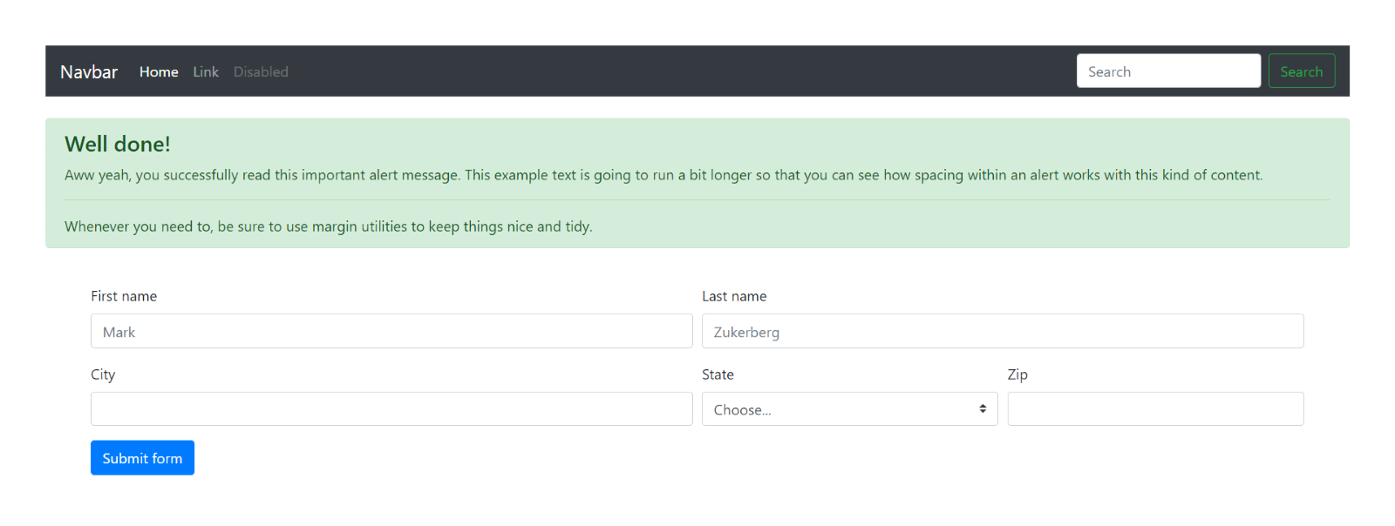

Practical 7🡺

Creating web pages using PHP.

HTML:

<!DOCTYPE html>

<html lang="en">

  <head>

    <meta charset="UTF-8" />

    <meta http-equiv="X-UA-Compatible" content="IE=edge" />

    <meta name="viewport" content="width=device-width, initial-scale=1.0" />

    <title>Practical 7</title>

    <link rel="stylesheet" href="./Practical-7.css" />

  </head>

  <body>

    <div class="contact-title">

      <h1>Welcome To This Website</h1>

      <h2>We Are Happy To Help You</h2>

    </div>

    <div class="contact-form">

      <form action="Practical-7.php" method="POST" id="contact-form">

        <input

          type="text"

          name="name"

          class="form-control"

          placeholder="Your Name"

          required

        />

        <br />

        <input

          type="email"

          name="email"

          class="form-control"

          placeholder="Your Email"

          required

        />

        <br />

        <textarea

          name="message"

          class="form-control"

          placeholder="Message"

          rows="4"

          required

        ></textarea>

        <br />

        <input type="submit" class="form-control submit" value="Send message" />

      </form>

    </div>

  </body>

</html>

CSS:

body {

  margin: 0;

  padding: 0;

  text-align: center;

  background: rgb(34, 36, 0);

  background: linear-gradient(

    215deg,

    rgba(34, 36, 0, 1) 6%,

    rgba(9, 121, 118, 1) 51%,

    rgba(132, 0, 255, 1) 86%

  );

  background-repeat: no-repeat;

  height: 100%;

  background-attachment: fixed;

  background-position: center;

}

.contact-title {

  margin-top: 100px;

  color: #fff;

  text-transform: uppercase;

  transition: all 4s ease-in-out;

}

.contact-title h1 {

  font-size: 32px;

  line-height: 10px;

}

.contact-title h2 {

  font-size: 16px;

}

form {

  margin-top: 50px;

  transition: all 4s ease-in-out;

}

.form-control {

  width: 600px;

  background: transparent;

  border: none;

  outline: none;

  border-bottom: 1px solid #333;

  color: #fff;

  font-size: 18px;

  margin-bottom: 16px;

}

input {

  height: 45px;

}

form .submit {

  background: #ff5722;

  border-color: transparent;

  color: #fff;

  font-size: 20px;

  font-weight: bold;

  letter-spacing: 2px;

  height: 50px;

  margin-top: 20px;

}

form .submit:hover {

  background-color: #f44;

  cursor: pointer;

}

PHP:

<?php

    $name=$_POST['name'];

    $visitor_email=$_POST['email'];

    $message=$_POST['message'];

[$email_from='guriqbal1921032@gndec.ac.in](mailto:$email_from='guriqbal1921032@gndec.ac.in)';

    $email_subject="New Form Submission";

    $email_body="User Name: $name.\n"."User Email: $visitor_email.\n"."User Message: $message.\n";

$to="guriqbalsingh@yahoo.com";

    $headers="From: $email_from \r\n";

    $headers .="Reply-To: $visitor_email \r\n";

    mail($to,$email_subject,$email_body,$headers);

    header("Location: Practical-7.html");

?>

IMAGE:

